MINI PROJECT REPORT- DBMS
Submitted By,
SAI SIDDHARTH N (312824205090)
II YEAR
Dept of Information Technology
2024-2028 Batch



AGNI COLLEGE OF TECHNOLOGY
(An Autonomous Institution)
Approved by AICTE C Affiliated to Anna University
OMR, Thalambur, Chennai – 600130

S. No | Content | Page No
1 | Problem Statement | 3
2 | Frontend | 4
3 | Database & Query | 5
4 | Images of Mini Project | 7
5 | Conclusion | 14

Table of Content

Problem Statement:
- Create a Discount & Coupon Database for promotional offers.

- Overview:
We need to set up a Discount & Coupon Database for promotional deals. In the current competitive landscape, businesses rely on discounts and coupons to draw in and keep customers. But managing these offers manually can cause mistakes, misuse, and makes it tricky to track how they’re being used. This project aims to create a centralized database system that effectively stores, manages, and tracks discount coupons, ensuring everything’s accurate and easy to access.

- Objectives:
- Establish a well-organized database for discount coupon management.
- Efficiently store information about user, Coupons and transactions.
- Stop coupon misuse through validation processes.
- Keep tabs on coupon usage and when they expire.
- Enhance accuracy and cut down on manual tasks.

- Scope of the Project:
- The system will handle the creation and storage of discount coupons.
- Users will be able to see and use available offers.
- Admin can keep an eye on coupon usage and check their validity.
- The system will maintain customer and transaction records.
- The focus is strictly on a database system with basic features.

- Technical Stack:
Layer | Technology Used
Database | Standard SQL
Backend | Node.js / Express.js
Frontend | HTML5, React.js, Vite, CSS
Tools | Antigravity, MySQL Workbench

Frontend Development:
- The frontend of the application is developed as a “Single Page Application (SPA)” using React.js and Vite. It provides a responsive and dynamic user interface, ensuring smooth navigation and efficient interaction without page reloads. The design adapts based on user roles, offering a personalized experience.
Key Features:
• Role-Based Interfaces:
The system provides separate dashboards for Admin and Customer. Admin manages coupons and views usage, while customers can browse products, apply coupons, and view savings.
• State Management:
Enables dynamic component updates without reloading the page, improving performance and user experience.
• Modern UI/UX Design:
Designed using CSS with a clean layout. Includes hover effects, input validation and interactive elements.
• Backend Integration:
Axios is used to communicate with the backend and fetch real-time data such as coupons, products, and user details
.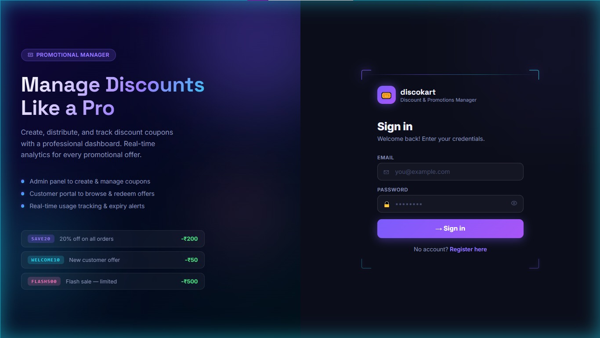
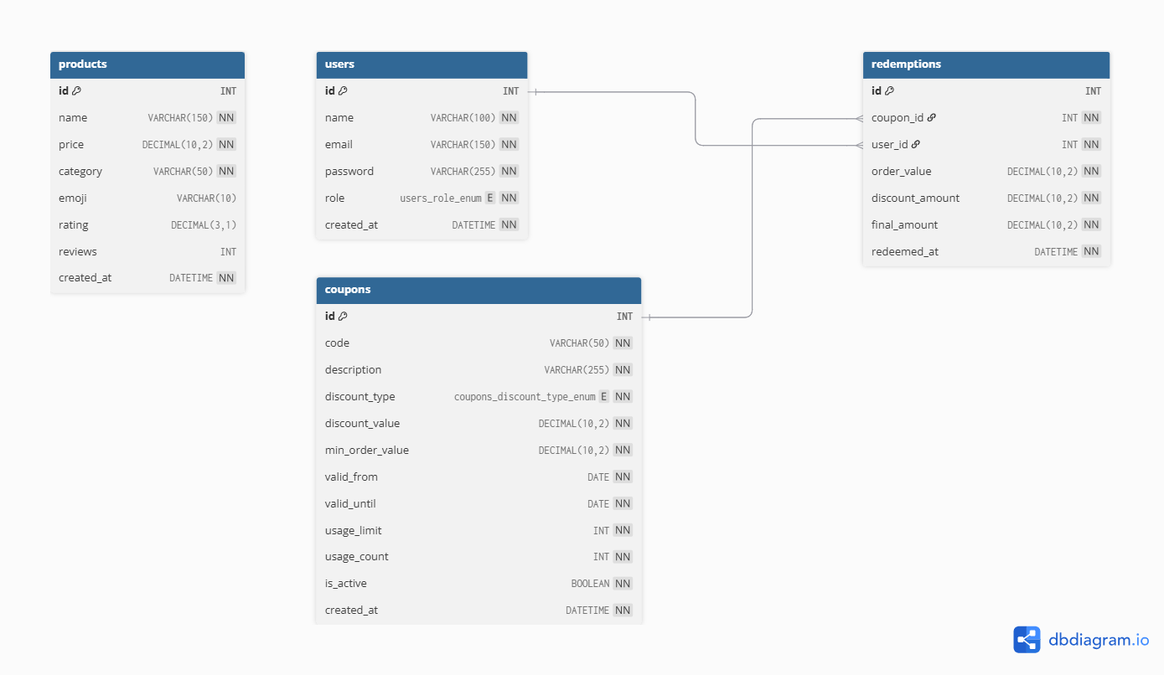
DATABASE & QUERY (with ER Diagram + Keys):
Queries:
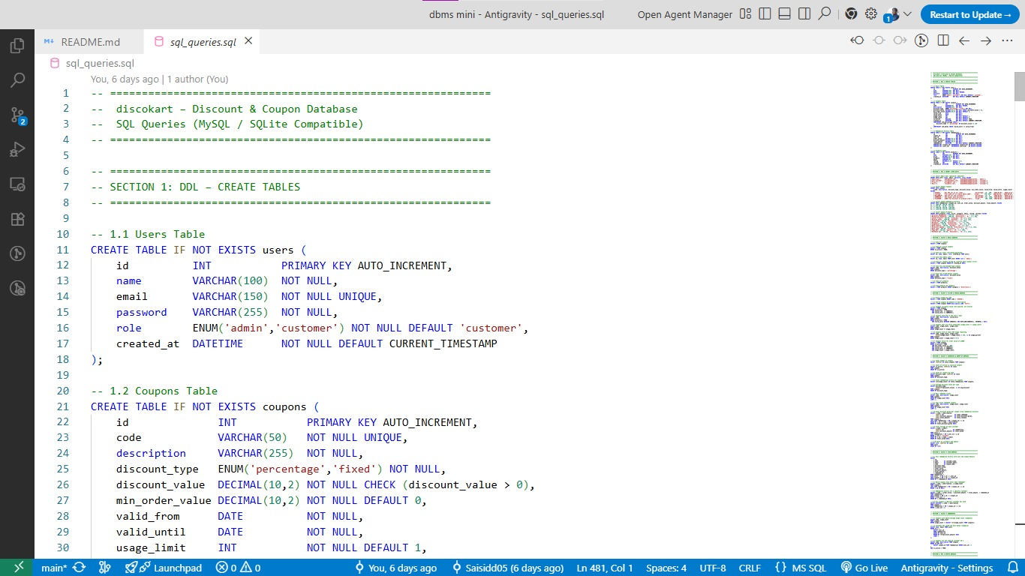

Tables:

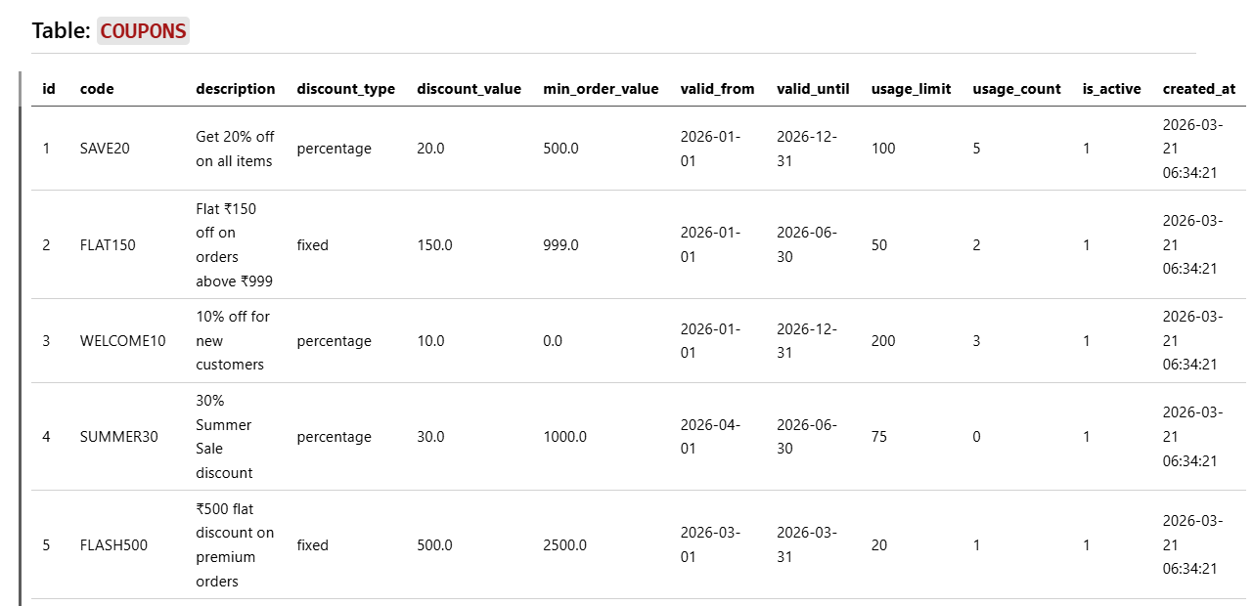
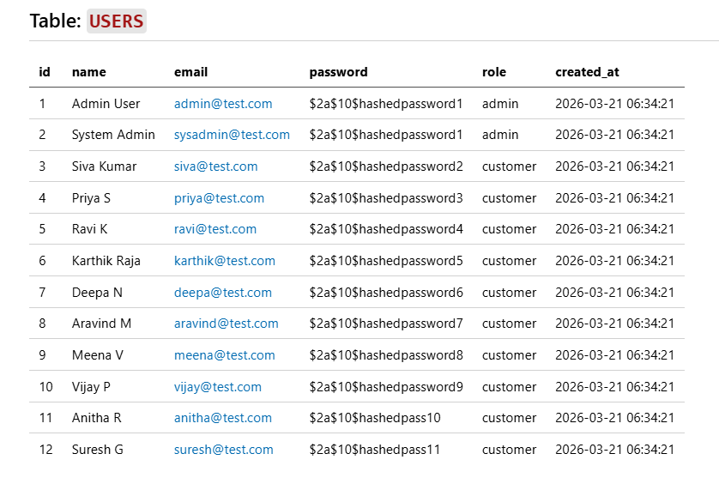

Images of UI/UX:

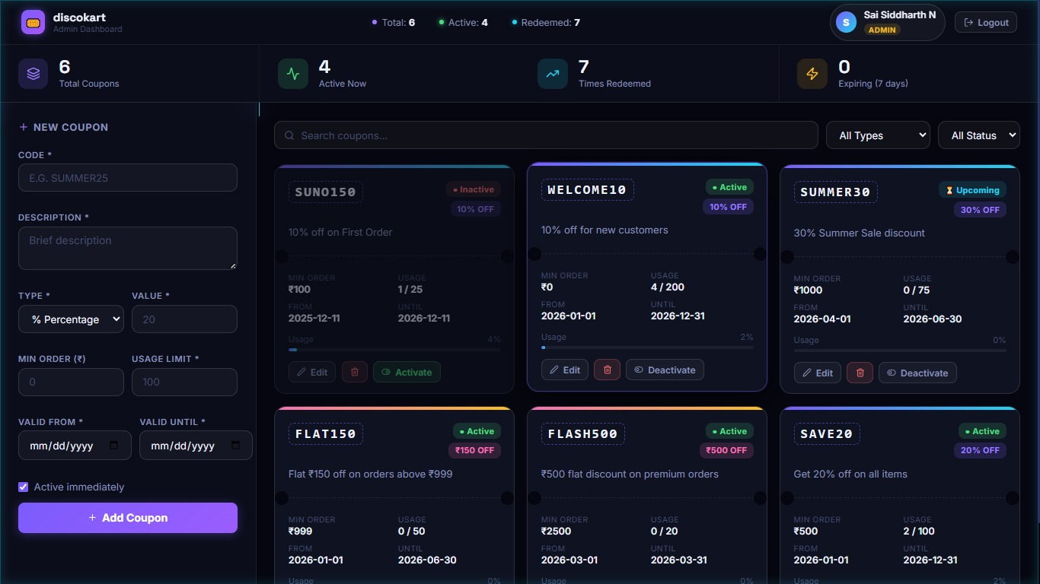

Admin Dashboard To do The CRUDE Operations in Coupons

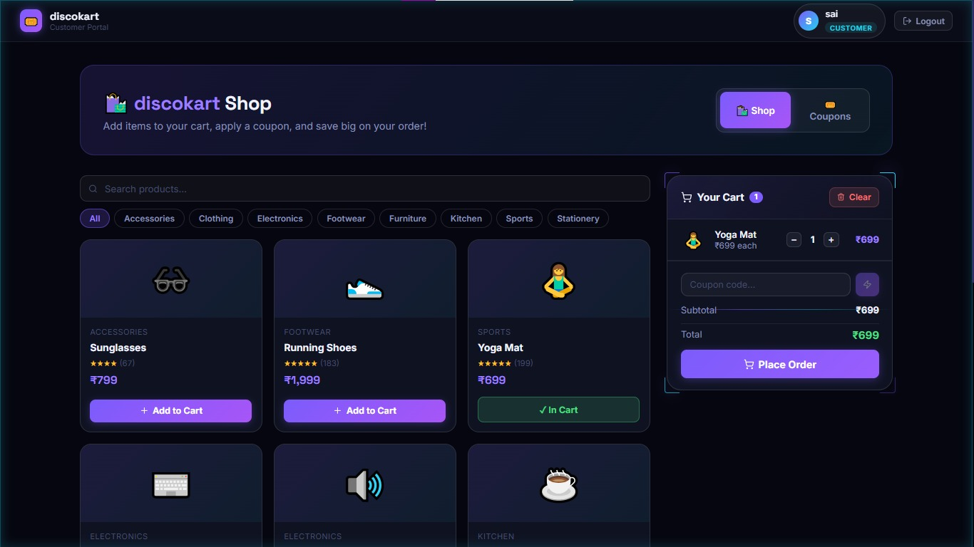

Customer Page to Add Items to Cart and Redeem the Coupons and Get Discount
Conclusion:
- The Discount and Coupon Database project really shows off how to design and implement a solid database for managing promotional offers. It takes care of everything from user info to coupon details, product data, and redemption history, all using a relational database setup. By splitting the data across several interconnected tables, the system keeps things consistent, accurate, and quick to pull up when you need it.
- With SQL queries for defining, manipulating, and retrieving data, managing real-time transactions—like applying coupons, updating how many times they’ve been used, and tracking customer savings—is a breeze. Plus, it uses advanced techniques like joins, aggregate functions, and views to dig into coupon performance and user activity, making the whole system way more dynamic and useful.
- In the end, the project hits its goal of making coupon management easier by cutting down on manual work and reducing mistakes. It lays a scalable groundwork that could be enhanced with cool features like mobile integration, advanced analytics, and real-time notifications. This project is a great example of how DBMS concepts can effectively tackle real-world challenges.

